Purpose of this doc:

1. Compile all information from lecture slides / announcements so we don't have to keep looking for it on Brightspace
2. Make it easier to keep track of our progress and designate tasks

Feel free to add / update anything, just let us know when you do

## To do

* Migrate the shared team agreement doc into the shared folder
* From meeting notes:
  + Need to do the report first, then use that for both the video and the presentation
  + Add a team contributions section to this doc and the report

## Calendar

| **Task** | **Assignee** | **Due Date** |
| --- | --- | --- |
| Redo team website | Sam | Before 11/19/21 |
| Create test visualizations and decide on 3   * Analyze the data in Tableau and send screenshots to the group chat to discuss | All | Before 11/22/21 |

## Overview of Project

Examples / References to look at

<https://www.in.gov/health/overdose-prevention/data/indiana/>

* This is almost too good, it uses Tableau, talks about drugs in Indiana, and is the official visualization for the state, look at it when you get a chance

### Learning Objectives

1. Determine what question to answer / problem to solve
2. Get additional data to supplement the dataset given
3. Provide insight into the defined problem and recommendations on how to solve it

### Our team must demonstrate that we:

* Understand the context and relationships within the dataset (who, what, when, where)
* Understand how the data provides wisdom and insight
* Can create new knowledge / insight from our analyses
* Can make predictions based on our findings

### The challenge / tasks

1. Identify and address a problem that is supported by the chosen dataset
2. Create a solution that provides insight / new understanding based on the given dataset as well as other acquired data
3. Make predictions / recommendations based on the findings / solution

## 

## Main considerations

1. What is our topic?
   1. Opioid abuse in Indiana
2. What question are we answering?
3. What is the problem?
4. Why is this a problem?
5. Why should anyone care / who is our audience?
   1. Note: must create a scenario where our visualization skills are needed for a specific user group, in order to optimize the vizzes for them
6. Where's the data?

## Deliverables

#### #1 Report - 65%

Due: 12/10 11:59pm EST (submit earlier since this is the last day of the semester)

* Make sure you use the correct version (v3.0)

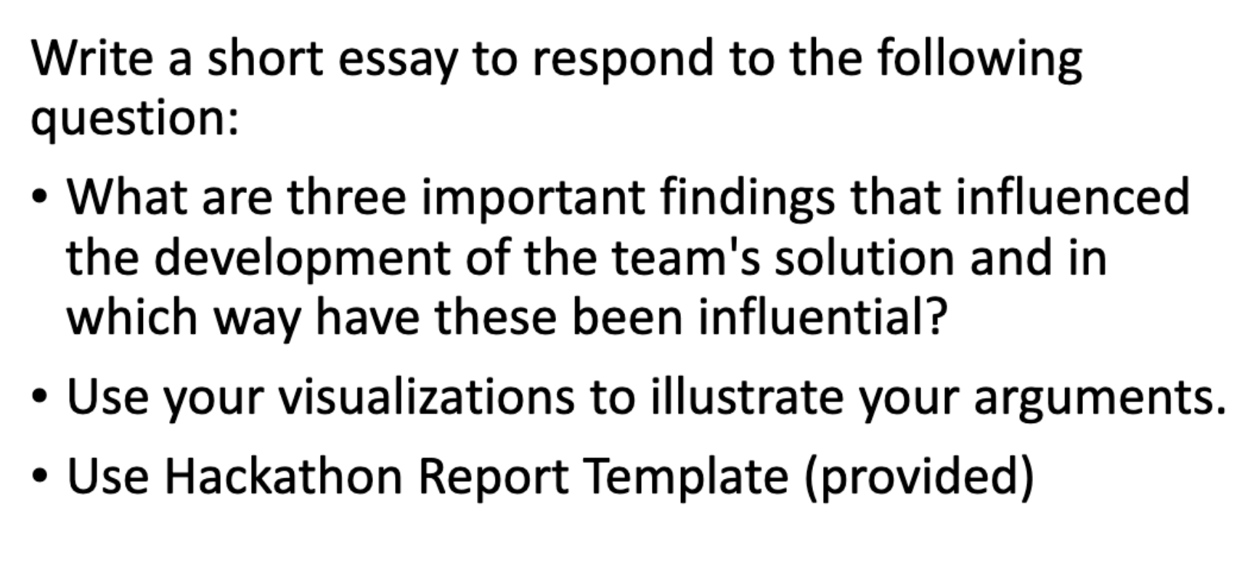

We can't alter the template, and must submit the most up to date version

Don't manually add content or it will alter the template

For reference, the best case's report: <https://web.ics.purdue.edu/~vbyrd/CGT270/Fall2020/Hackathon/HackasaurusRex_CaseDocument.pdf>

* Shows we don't have to have a huge paper, 2 - 3 pages should be fine

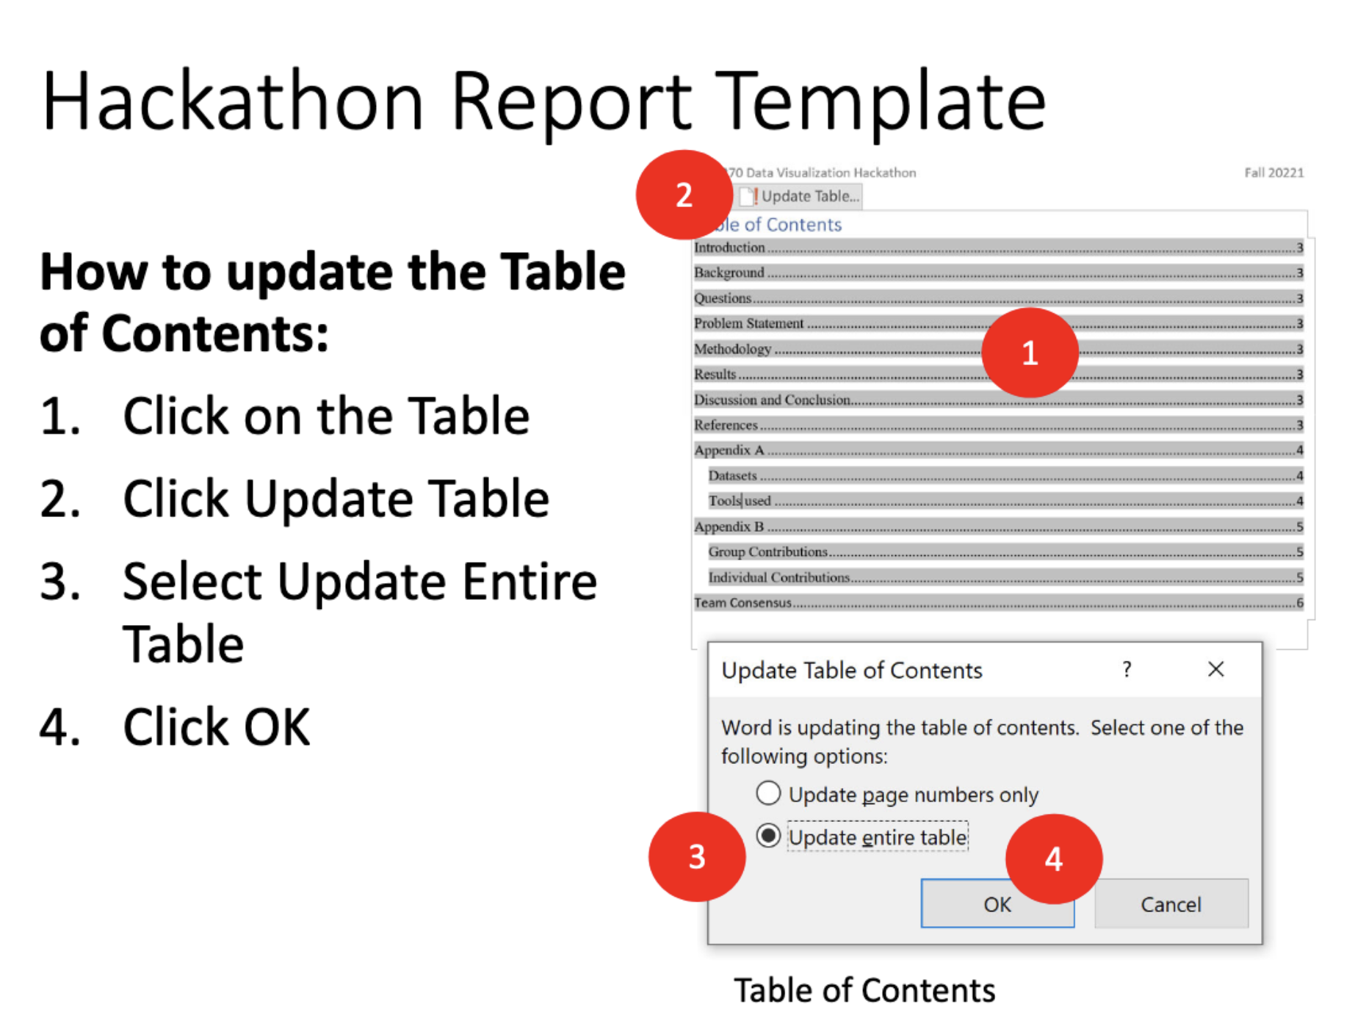

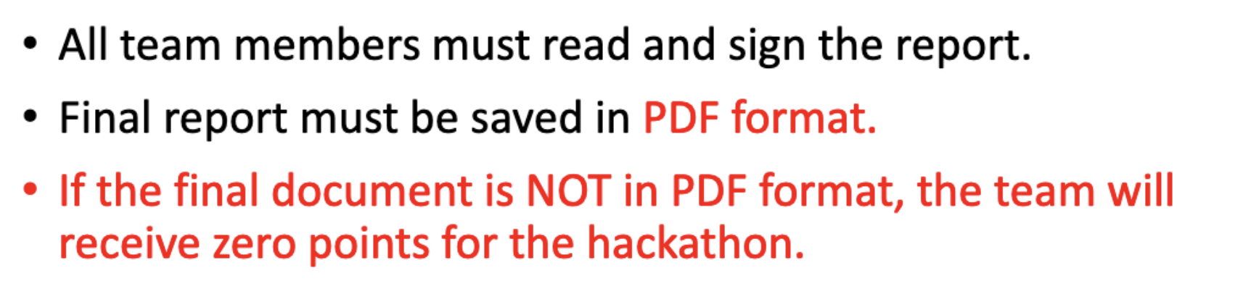

#### #2 5 Minute Video - 20%

Due: the day before we present - 12/8

* Due BEFORE NOON the day before we present!!

Need to tell the team's story, start to finish, being compelling / tasteful

* This doc will be useful: [Hackathon Visualization Process Notes](https://docs.google.com/document/u/0/d/1j3gSw6VKkBajSZkR5Fj6PB2-m4JRAiRXGeS8i-Xvodk/edit)

#### #3 Project Website - 5%

Due:

* Prototype: 11/19 (must have a link to provide by this time)
* Finished: 12/10 11:59pm EST (same as report)

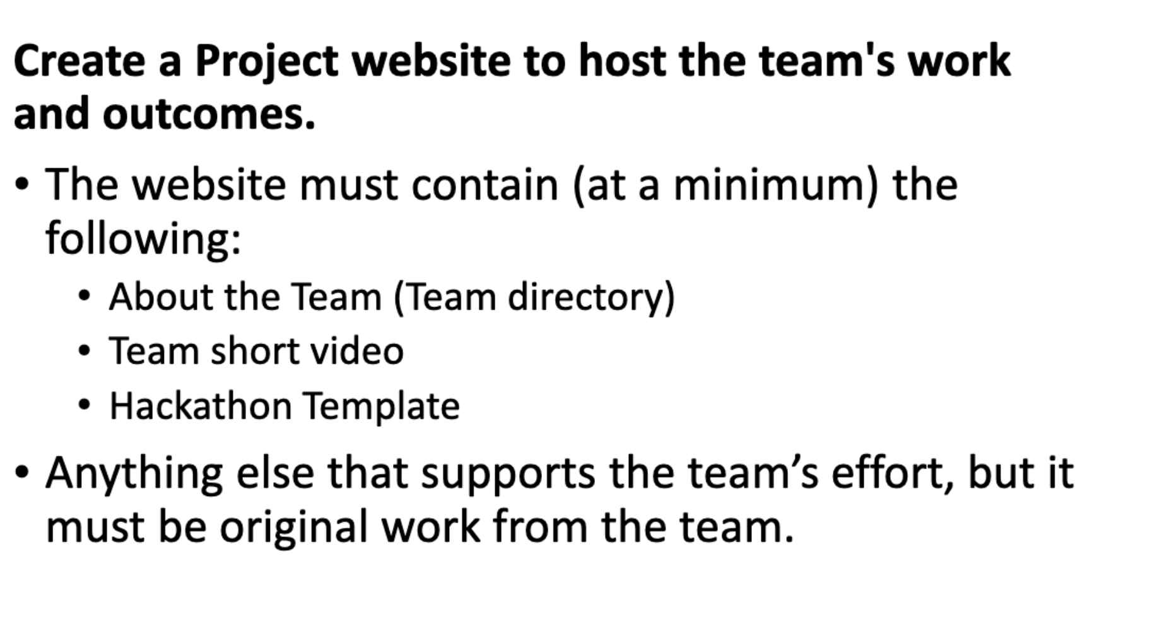Ideas:

* Web storm?
* Look at past team's websites for standard

#### #4 Presentation + Q&A - 10%

Our slot: Thursday 12/9 10:30am - 10:40am

* (Please don't join any other time slots, as we'll get a 0 if we do)
* First 5 min is presentation, last 5 is Q&A
* We are right after the 10 min break, not sure if that makes any difference

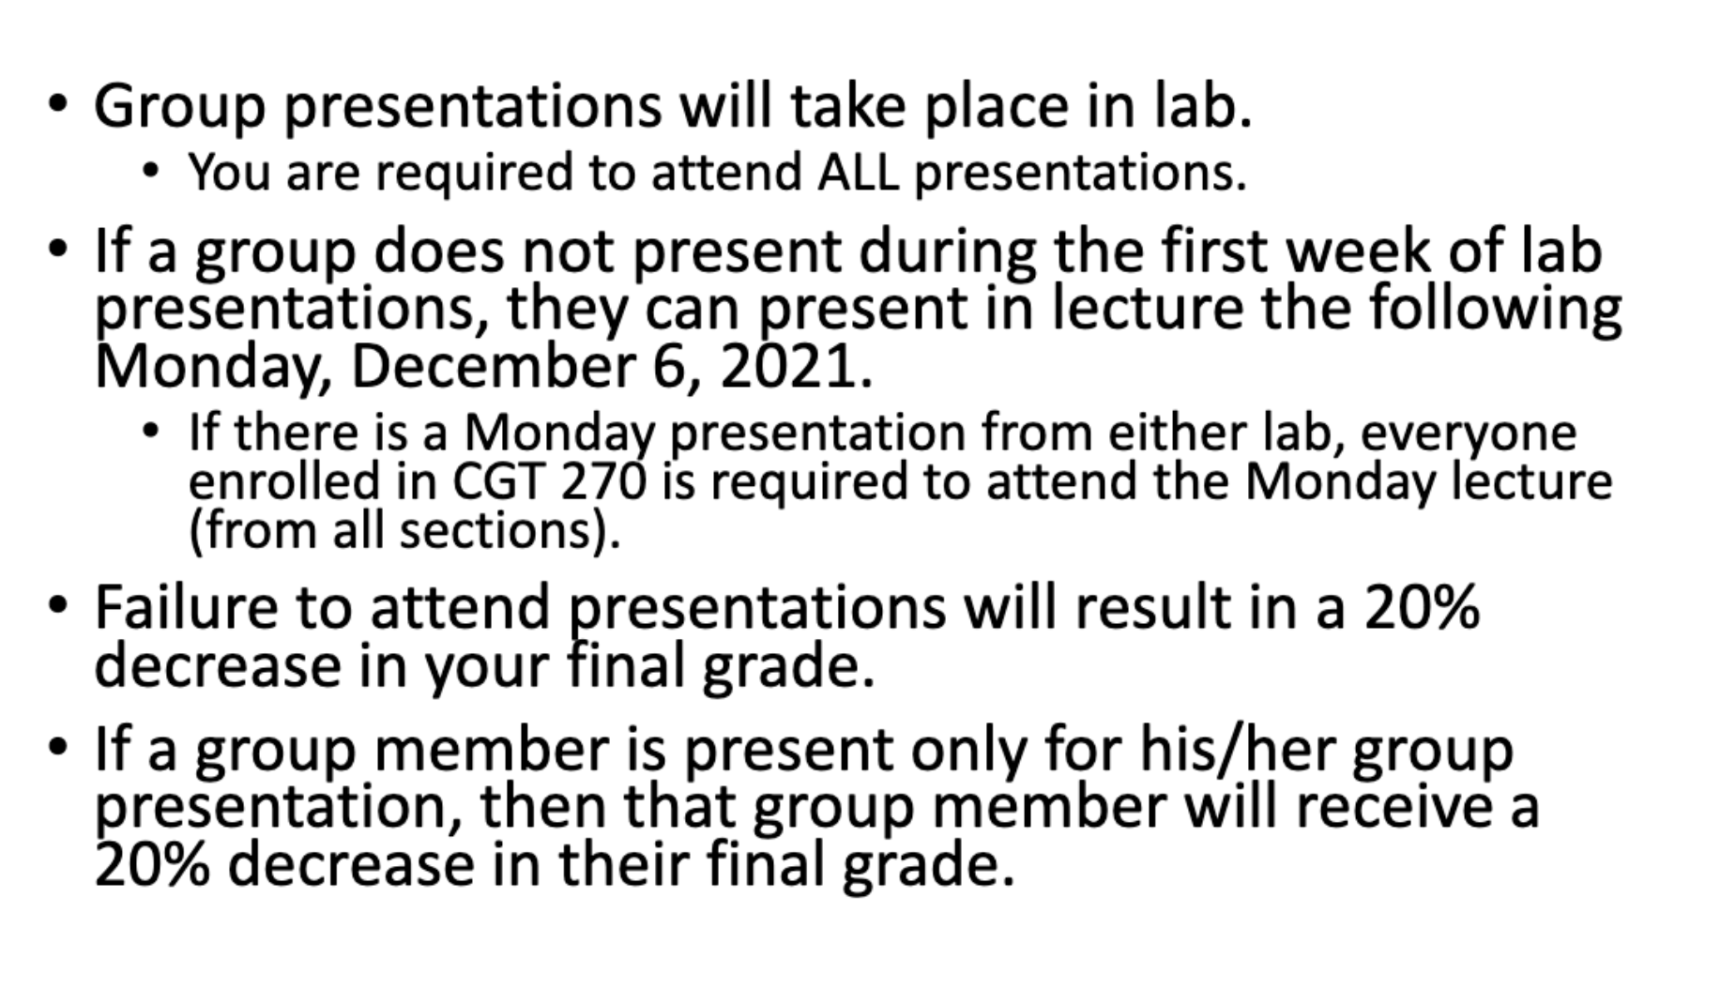

## Brainstorming Notes

What we can't choose (for mm4):

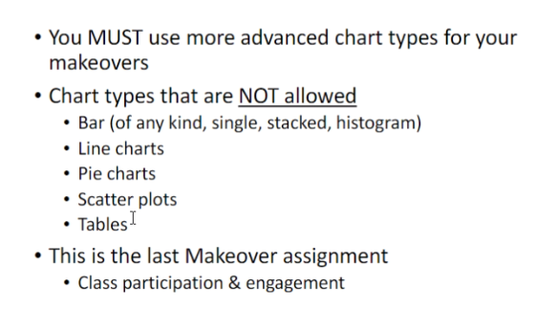

Ideas on visualizations to do

* A map of indiana?
  + Put where the most usage is at by city
  + Data uses county
  + Also depends on the supporting data

Ideas for problems:

* Compare opioid drug abuse to a different drug abuse
  + Could do one or two other drugs, could do with a map with pie charts for each state

## List of ALL Assumptions

From analyzing datasets:

* Given demographic dataset
  + Assumed drugs 9143 and 9652 referred to the DEA numbers of oxycodone and oxymorphone, respectively
* Given frequency dataset
  + 'W', 'b', and 'h' stand for white black and hispanic, with 'drug' = the sum of those three
    - Note: the sum doesn't always equal the value it should, we will need to decide how to handle that
    - What does opioid mean?
      * Probably the amount of opioid retrieved from users within the three races or
      * The number of users found using opioids
  + Assumed all values mean are the count of people that have taken / used that drug in the given year